dn

Recipients

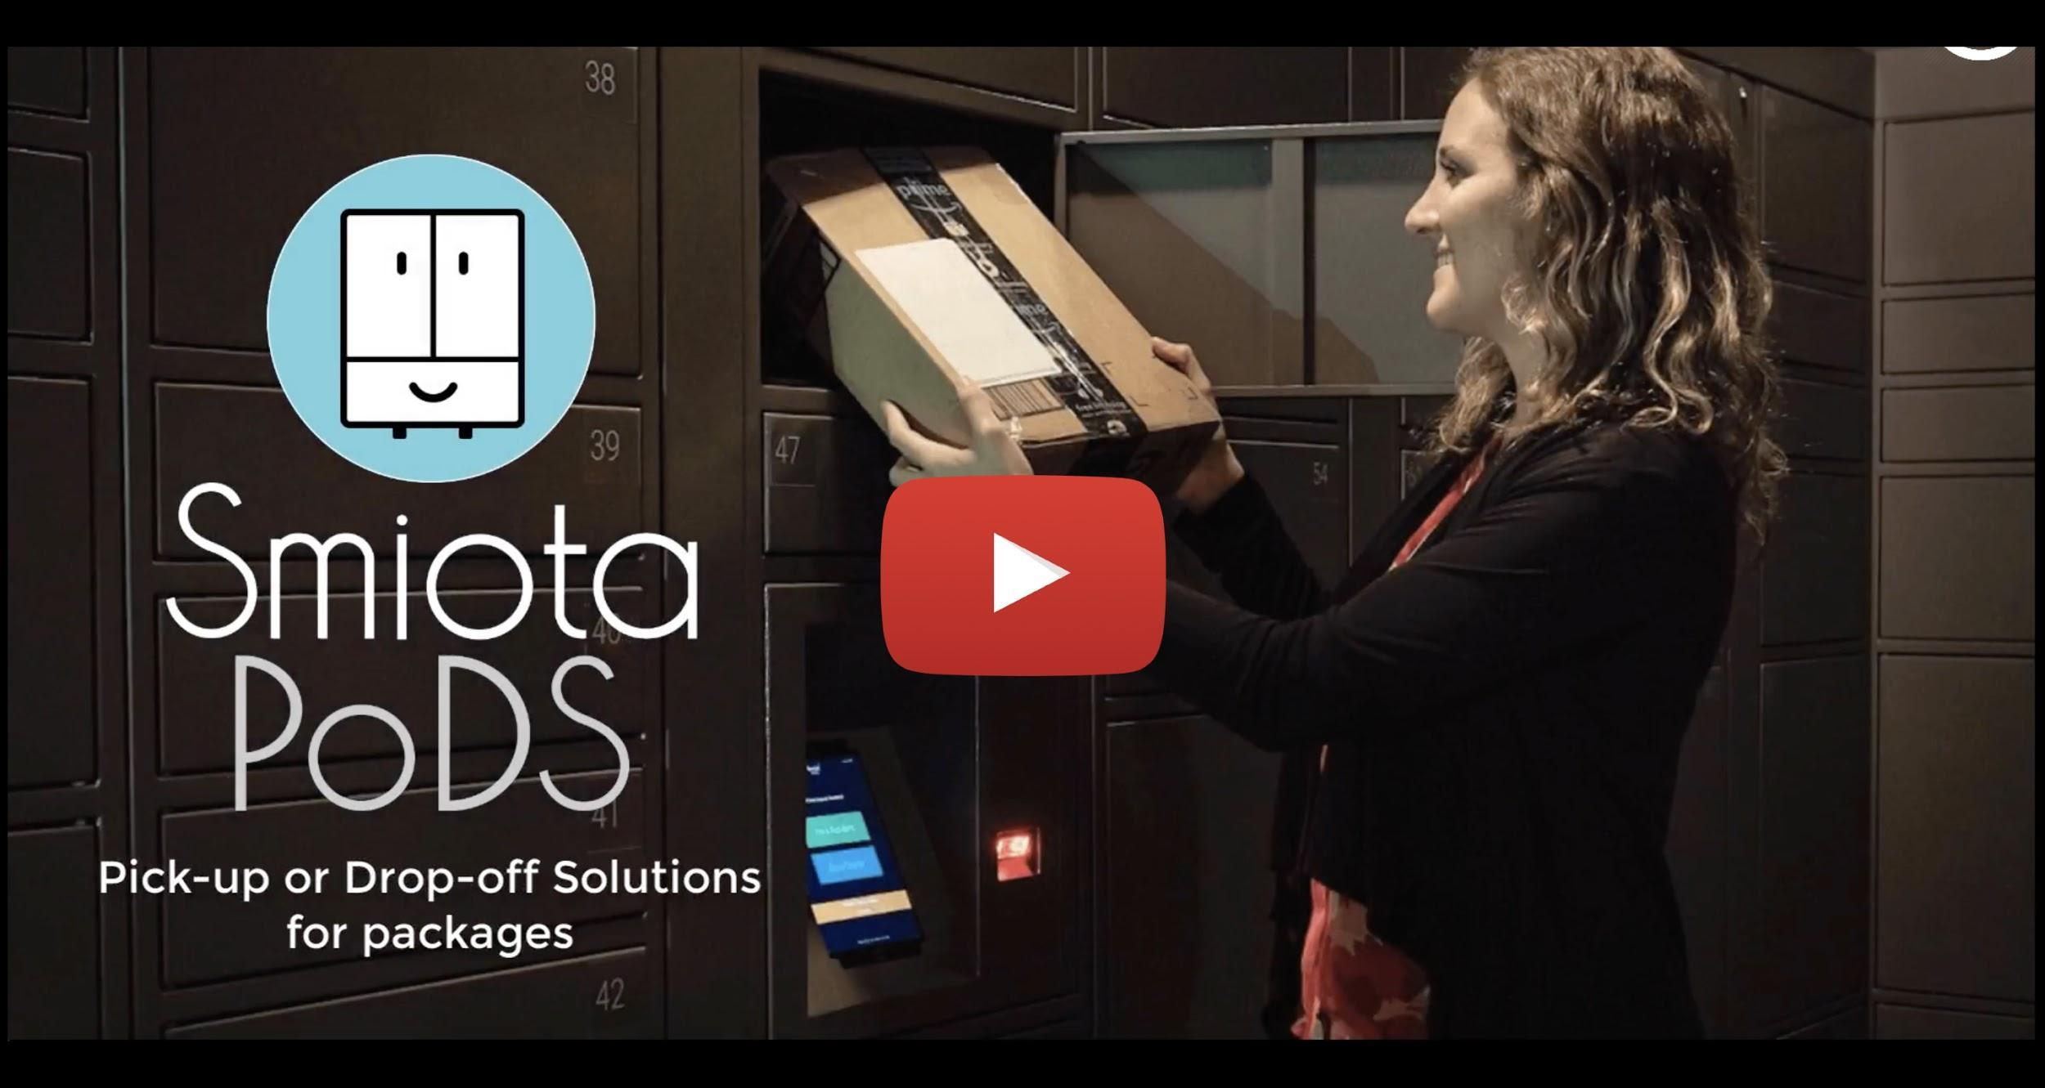

Training Videos

How do I access the lockers?
Click on the link below or the thumbnail image on the right to open the YouTube video

How to Access Lockers

How do I install Smiota app?
Click on the link below or the thumbnail image on the right to open the YouTube video

How to Install Smiota App

Set-Up

Do I need to sign up or register to use the PoD?
No. However, your contact information should be in your property management database to receive the notification when your package(s) are deposited into lockers.

Do I need to provide the credit card information to use the PoD?
No. It is a free amenity (for 72 hours) provided by property management.

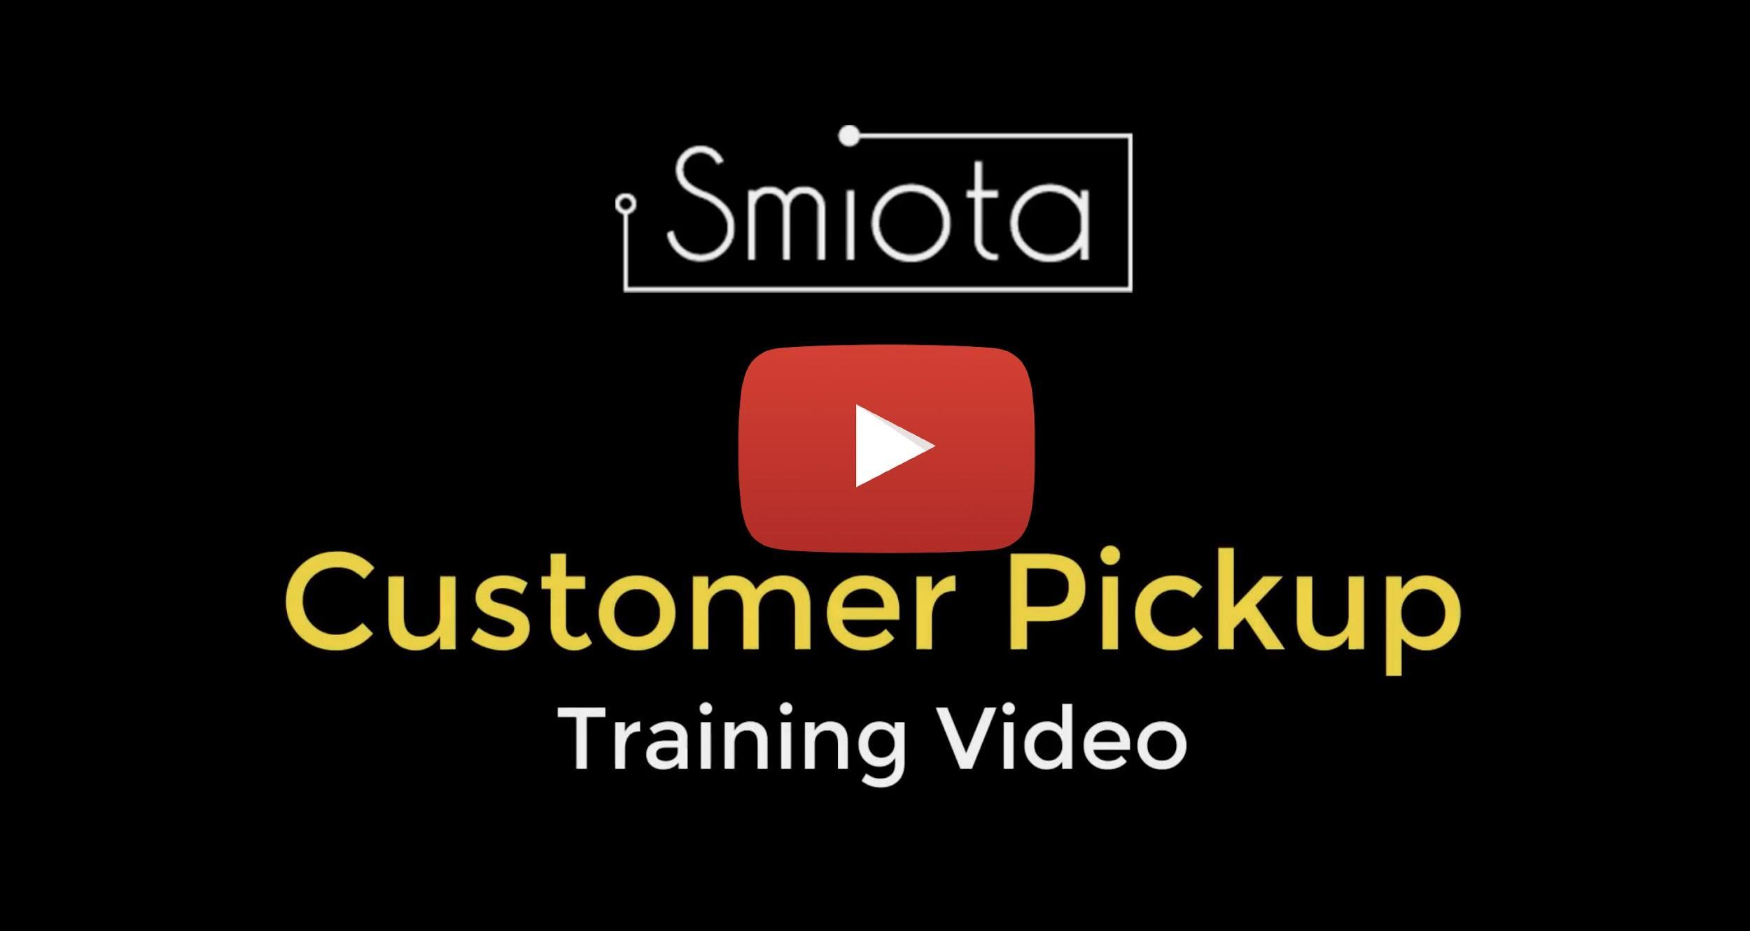

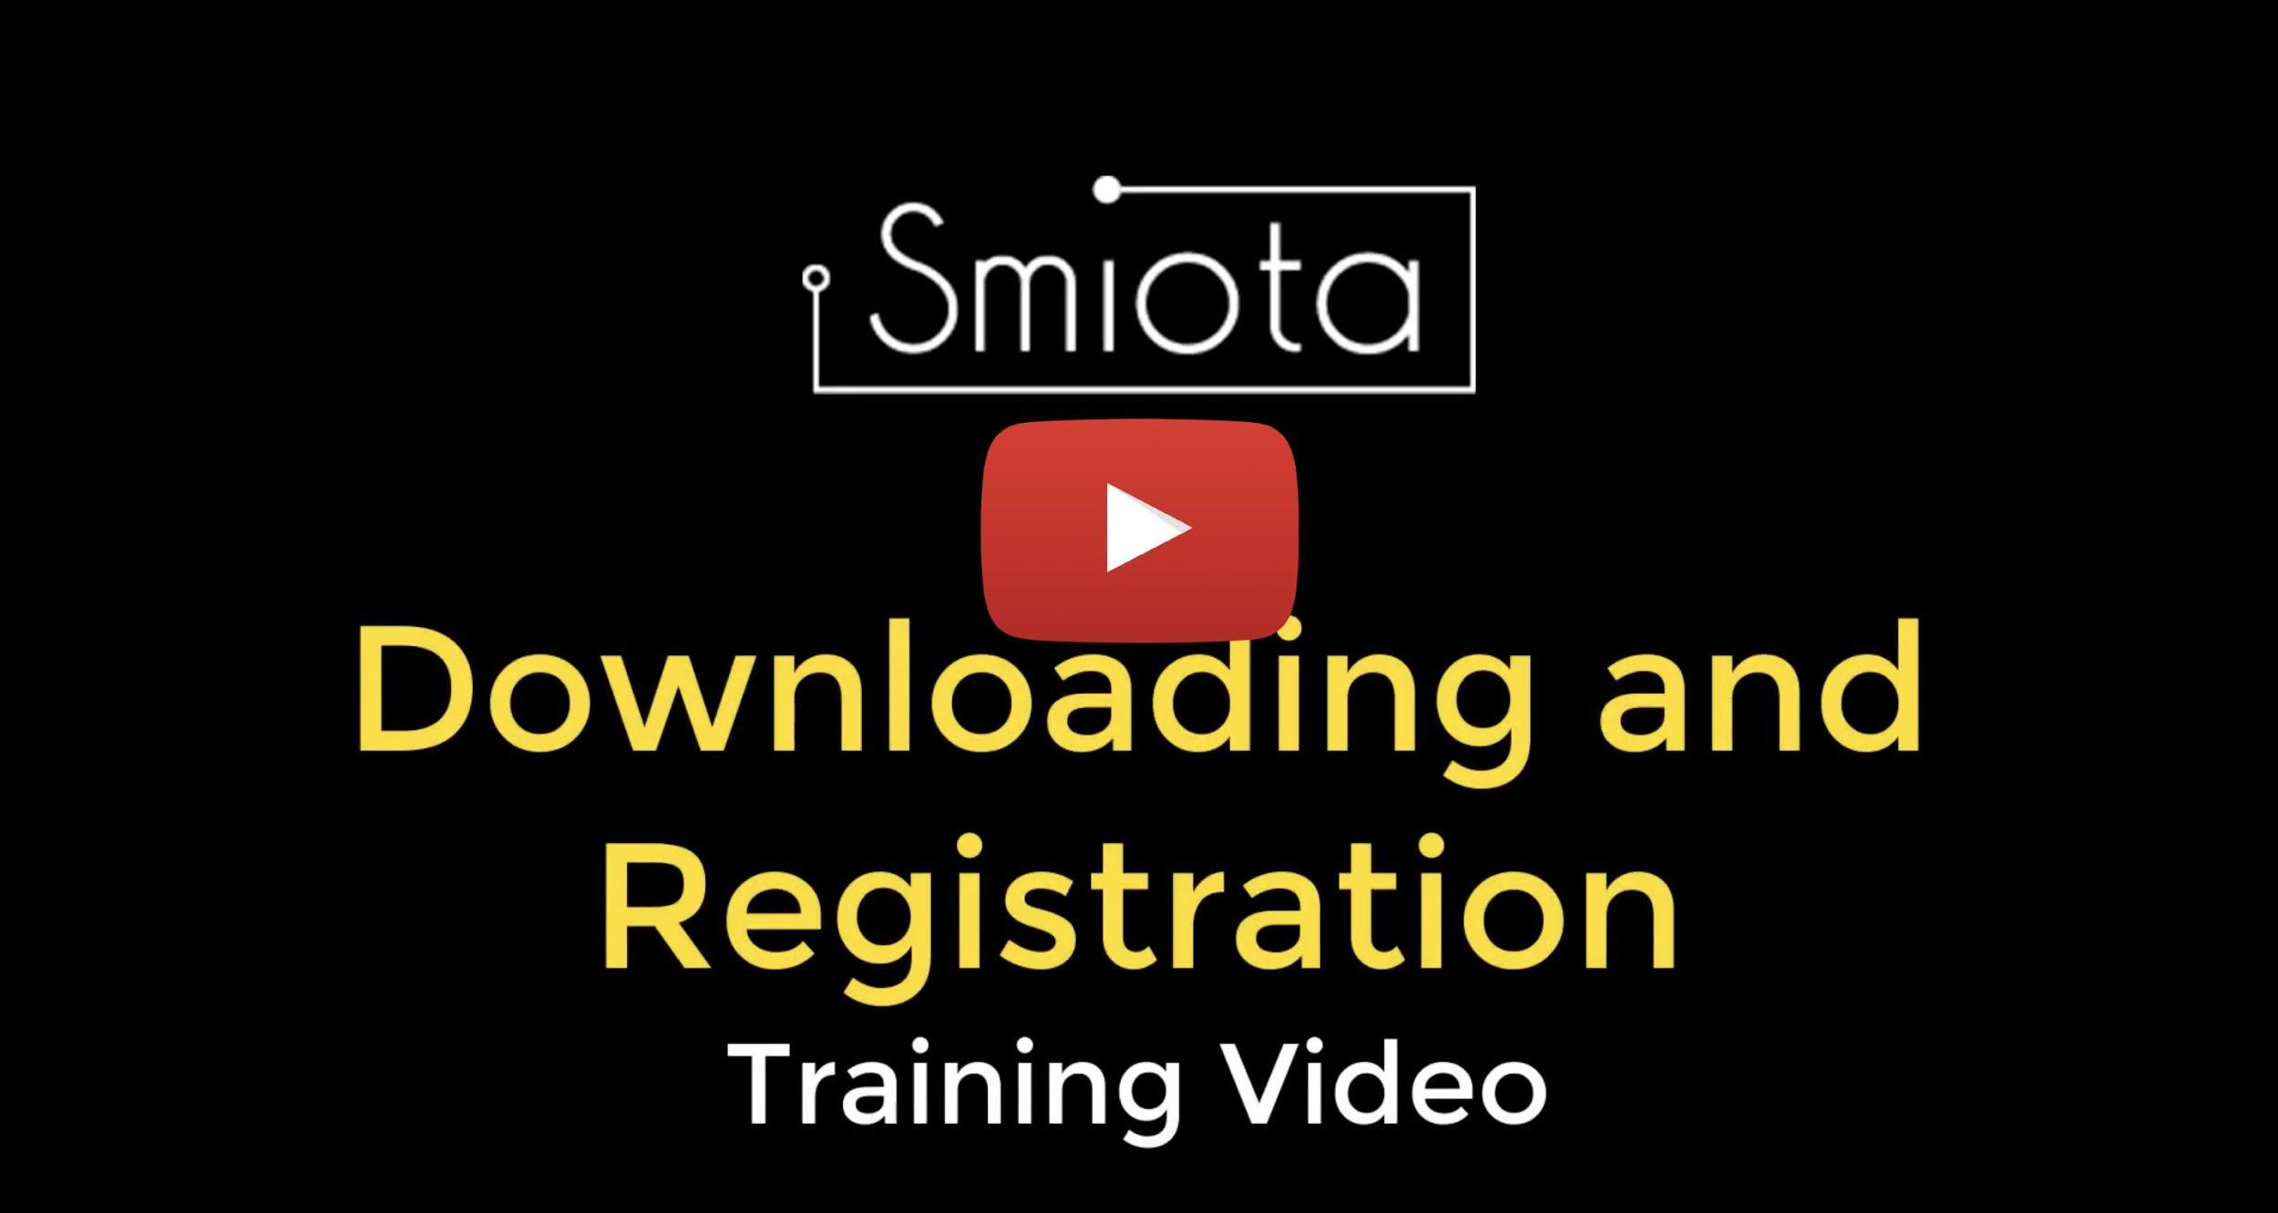
Can I opt out of participating in the locker system?
Email your property management requesting to opt Out of the service. The management will set the Opt Out flag at the back end. When carrier/courier chooses an Opt Out recipient on the app, a message on the screen instructs carrier/courier to deliver package at the door of the recipient.

Where are the lockers located?
The lockers, labeled Pod 1, Pod 2, and Pod 3. You will see signs on the doors. Pod 1 and 2 are at the Terrace Center Den hallway. Pod 3 is at the Terrace Center Mailroom, next to the Terrace Center Valley Housing Office.

How do the system work?
The above training videos will give you in depth knowledge of how the system work.

For more information, please review the FAQ document for a complete system operation.

What address should I use to ship my package(s)?
Your mailing address must be your room address:

Name
Room # and building name
Merced, CA 95340

For example:
Carla Ramos
5400 N. Lake Rd
Rm. 113 Half Dome
Merced CA 95340

What are the hours I can pick up my package(s) from the locker?
The pods will be accessible 24/7, 365 days a year.
Can someone pick up my package(s) for me?
Yes, you can forward the access code sent by the system to your friend or a family member to pick-up your package(s).

How long can my package(s) be in the locker before I get charged?
Recipients will have 72 hours after carrier/courier deposits the package into the locker before a fee of $2 per day is initiated. Fees will be billed directly to the recipients’ account.
This is due to the volume of packages and a finite
number of lockers, we do need lockers emptied for maximum availability.

What if I am out for an extended period of time?
Allow your friend or a family member to pick up your package(s) by forwarding them the locker access code received by the system. OR

You can also arrange for your packages to go to your office by clicking on “Delay in Picking up…” option in the email notification sent by the system where they can be held for an extended period. This message then will be received by the property management.

But to be considerate of your neighbors please don’t plan on holding packages in lockers longer than 3 days.

How do I know I have a package?
You will receive a text message and/or an email message with an access code to pick up your package(s) from the locker.

What if I don’t have an email or cell phone?
You cannot receive packages into Smiota PoDs without a valid email or phone number. Please ensure your email or cell phone number is updated in the myUCMerced log in system.

Can I get food delivered?
We are unable to accept food or similar items like fresh flowers. Those Vendors should always be directed to deliver to a pick-up area outside the building.

What if my guest has a package delivered under their name but with my address?
We cannot accept guest packages if it is under their name. You need to update the property management system with the guest name for lockers to accept guest packages.

What will happen with mis-delivered package(s) - for example a package(s) is under my name, but the address was shown incorrectly?
The courier deposits package(s) based on your name displayed on the screen. If package(s) is/are mis-delivered, please return package(s) to leasing office.

Are the roommate(s) and/or children included in the system?
Roommates - Yes, as long as we have their proper contact information they will be notified directly.

Kids - Yes, if they are named on the lease as “minor Occupants” the primary Leaseholder would be notified a package has been delivered. (UC Merced does not currently offer family housing)
Can the system accept all packages?
There are a very limited number of large lockers that can accept package(s) that are 36”x15”x24”. When carrier/courier(s) select “Package does not fit” option provided in the app, they are directed to deliver the packages(s) to recipients’ door. Also, the notification will be sent to the recipient that the package will be delivered at the door.
What happens if all the lockers are full?
We don’t anticipate this as we have purchased more than the recommended number of lockers for a property of this size. We will also be training the carriers/couriers, whom we are able to contact, for several days as the system is tested. We also request recipients to pick up their package(s) promptly.

However, if the lockers do get full, the app does display “All lockers are full…”. In this case, carriers/couriers are directed to deliver the package(s) to recipient’s doors or mailboxes – as they always have been. What we don’t want is carriers/couriers dropping off packages in the package room versus inside a locked locker – that would defeat the purpose.

As always, the completion of a package reaching its destination is ultimately the carriers/couriers job. You have paid for a delivery service and If there are delivery problems, you should contact the package carriers/courier (UPS, Amazon, FedEx, etc.). Also, please note the recipient Services Office will not be accepting any packages once the locker system is up and running.

If I receive more than one package, will they all be in the same locker?
Most commonly, packages will be in different lockers. Packages processed on the same day, for the same resident, may be placed in the same locker together. Smiota tracks these individually and will prompt placement in the same locker.

How do I pick up my package(s)?
You will receive a text or email notification with a unique access code and QR code after your package is delivered at the PoD. Smiota provides 3 easy and convenient options to pick up your package(s)

- Enter Access Code - On the screen, Tap on Green (I’m a recipient) Tab and enter access code to open locker(s) and pick up package(s)
- Scan QR code - Click on the email/text notification link to display QR code on your smart phone, hold it 6 inches from the red scanner. The locker(s) with your
- Smiota app - If possible, download the Smiota app from iOS App store for iOS devices or Google Playstore for Android devices. When you are near the PoD, launch the app and click on open locker doors (green bar) to pick up the package(s). You can also see your package history and many other features.

What if the locker doesn’t open when I enter my access code?
You might see the pop message on the tablet “No Recipient was found with the given passcode”
The possible cause:
- Package(s) may have been picked up already
- Wrong access code could have entered
- Instead of tapping on “I’m a recipient” you might have tapped on “I’m a Courier”
- If none of the above is true, if possible,
Download Smiota app from App Store (iOS) or
Play Store (Android). This will show exact
package information if you have any in the
system. OR
contact Smiota Support
support@smiota.com OR call (925)390-3033

Accidentally closed the locker door without picking up the package?
No worries, you can use the same code to access the locker again.

Accidentally deleted access code notification?
Please call 209-228-4663 and they can resend the access code.

If possible, download the Smiota app to avoid this situation.

Are the locker(s) too high to pick up your package(s)?
Request your property management for lower level locker option. When the carrier/courier chooses your name, the system automatically will open the lockers that are below 4 ft.

Are you seeing connecting to locker… on the app?
Contact Smiota Support support@smiota.com OR call (925)390-3033

Are you seeing Reset PoD message on the app?
PoD needs a reboot. Takes less than a minute for a Smiota Personnel to take care of it.

Contact Smiota Support support@smiota.com OR Call (925)390-3033

Are you seeing “Unable to connect”?
Network connection could be down.

Connect your phone to the apartment’s network connection to see if the Wi-Fi connection is strong. If the connection is weak, notify your property management OR

contact Smiota Support support@smiota.com OR Call (925)390-303

